

Bundamba Outside
School Age Care Enrolment Forms
2026
Allery/Asthma Plan Completed Yes_____ No_____
Immunisation Record attached Yes _____ No_____
Immunisation records sighted Yes_____ No _____

Updated October 2025
Bundamba School Age Care
Brisbane Road, Bundamba 4304 Telephone: 3816 6654 Mobile 0472652277
Enrolment Form 2026 | Hours  Before and After School Care: 6.15 a.m. – 8.30 a.m.  2.45 p.m. – 6.15 p.m.  Vacation Care  6.15 a.m. – 6.15 p.m. |  | ALL INFORMATION CONTAINED IN THIS FORM IS CONFIDENTIAL AND FOR CENTRE USE ONLY
Family Name: PARENT CRN

Child Details
Children’s Names:
- Date of Birth: / / Class: Male/Female Address CHILDS CRN
- Date of Birth: / / Class: Male/Female Address CHILDS CRN
- Date of Birth: / / Class: Male/Female Address CHILDS CRN
- Date of Birth: / / Class: Male/Female Address CHILDS CRN
Parent/Guardian details: 1  Surname: Name: D.O. B Address: |  | Parent/Guardian details: 2  Surname: Name: D.O. B Address:
Home Telephone: Mobile: License No. Email: Work Details:  Workplace: |  | Home Telephone: Mobile: Relationship to Child: Work Details:  Workplace:  Telephone:
Telephone:
EMERGENCY CONTACT AND/OR AUTHORIZED TO COLLECT DETAILS: (Different from above guardians)
Name: Relationship:

Address: Phone Home: Authorized to Collect-(circle) Yes, No Work/Mobile-

Name: Relationship:

Address: Phone Home: Authorized to Collect-(circle) Yes, No Work/Mobile-

Name: Relationship:

Address: Phone Home: Authorized to Collect-(circle) Yes, No Work/Mobile-
Page 1

Bundamba School Age Care
Brisbane Road, Bundamba 4304 Telephone: 3816 6654 Mobile - 0472652277

Booking and Attendance Details:

Attendance  Permanent: Starting date  Before School Care After School Care  Monday - Monday-  Tuesday - Tuesday-  Wednesday- Wednesday-  Thursday - Thursday-  Friday - Friday- | Attendance  Casual:  Starting date:
For casual bookings -
Please contact us via text or email by Friday for bookings the following week. All casual bookings are charged at a higher rate than Permanent rates.
All absences will be charged.

Direct deposit details
Bundamba State School P&C
Account number: 169150117
BSB: 633 000
Reference: Your name/Childs name
Are there any Custody Arrangements? Yes /No
Separated/divorced:
Who has custody of this child? Is anyone denied access to this child: Does the child have contact with the other parent? Copies of relevant court orders Any Additional Information:

CCS AGREEMENT
I (parent name) understand that under the CCS system my account needs to stay owing under $100 otherwise my enrolment may be suspended until my account is under $100 owing.

Signed-
Emergency Details:
DATE

Action Required in Emergency: Medicare Number:
Family Doctor: Phone Number- Address:
I give my authorisation to staff to give emergency medical attention/ first aid
(signed) (date)

Page 2

Bundamba School Age Care
Brisbane Road, Bundamba 4304 Telephone: 3816 6654 Mobile: 0472652277

Child/Children Medical Details and Medical History:
Does your child/children suffer from asthma? Yes/No Mild/Severe/Anaphylaxis
Asthma form completed: Yes/No Doctors letter supplied: Yes/No
Child name(s): Details: Medication Required: Does your child/children suffer from any allergies? – Yes/ No Mild /Severe/Anaphylaxis
Allergy form completed: Yes/No Doctors letter supplied: Yes/No
Child name(s): Details: Medication Required:
Does your child/children suffer from any medical condition that may require medical treatment/ medication? – Yes/ No
Medication form completed: Yes/No Doctors letter supplied: Yes/No
Child name(s): Details: Medication Required: Please note:
If your child has ASTHMA, ALLERGIES, DIABETES or MEDICAL TREATMENT/MEDICATION and we require a medical management plan to be submitted before the child begins attending our centre. The centre will then develop a risk minimisation plan for your child.
- Please note all medication must be accompanied by a letter from your doctor.
*Required to be in its correctly labelled pharmaceutical box/bottle/tube if it needs to be administered during S.A.C. hours.
Does Your Child/Children Have Any of The Following: -
If you have more than one child, please print the name of the child affected as well as the information.

  - Disabilities:

Official Diagnosis (Copies of doctor’s letters/documentation to be provided before child begins care)

Medication Required: - Yes/No Form Completed Yes/No
  - Special Medical Needs: -

Medication Required: - Yes/No Form Completed Yes/No

  - Physical Needs: -
Emotional Needs

  - Likes/Interests: -

  - Dislikes/Fears/Phobias: -

  - Dietary Needs: -

  - Religious Beliefs: -

  - Is your Child/ren aboriginal or Torres Strait Islander decent Yes/No
  - Cultural Needs/Requirements: -
  - Languages Spoken by the Family;
Any unique issues to assist us-
Page 3
Bundamba School Age Care
Brisbane Road, Bundamba 4304 Telephone: 3816 0833
Please read the information below and information contained in the Parent Handbook carefully before signing this form.
- All accounts are to be paid weekly and always kept in CREDIT. Accounts outstanding for more than 7 days are referred to the P & C Committee and the enrolment may be suspended until account is fully paid and in CREDIT! Accounts can be paid by eftpos or direct deposit ONLY!
- Where possible, in an emergency, we will contact parents/guardians or other nominated emergency contacts prior to or as soon as possible after seeking necessary medical treatment for the child.
- Any costs associated with emergency medical attention obtained while a child is attending School Age Care are the responsibility of the Parents/guardians.
- No medication will be given to a child without the prior written consent of a Parent/guardian. Only medication prescribed by a Medical Practitioner will be given to children attending School Age Care.
- Care may be refused for any child who arrives at the Centre ill or suffering a contagious illness. If a child becomes sick while at School Age Care, the child will be made as comfortable as possible while the Parents/guardians or other authorised people are contacted to collect the child.
- No child may leave the school grounds or attend excursions without the prior written consent of Parents/Guardians.
- The Nominated Supervisor may exclude certain children from planned excursions/activities. Where such action is considered necessary a minimum of 24 Hours’ Notice will be given.
- The Nominated Supervisor may exclude any child from the program, whose behaviour is considered a danger to themselves, other children, or staff. The Nominated Supervisor may exclude children whose behaviour is consistently inappropriate from the Program, with approval from the P & C Committee. A minimum of 5 working days’ notice will be given in such cases.
- All Child’s enrolment information gathered in this form will be backed up on the Bundamba Primary State School’s Education Queensland Server to avoid loss of information cause if the building and its property are damaged.
Parents’ Responsibilities:
  - To ensure that all accounts are paid up to date and where there is any difficulty paying an account, notify the Nominated Supervisor as soon as possible.

  - To advise the Nominated Supervisor immediately of any problems at the Centre regarding their child or concerns regarding other children.

Parental Agreement:
I HAVE READ THE ABOVE CONDITIONS OF ENROLLMENT AND AGREE TO THEM AS OUTLINED.
I hereby apply for enrolment of my child at the Bundamba School Age Care program, conducted at the Bundamba State School. In the event of sudden illness or accident I hereby authorise the person in charge of the Centre at the time to follow the guidelines set down in the Centre’s Policy document. I undertake the following: “To inform the Centre’s Staff of any absence of my child; to keep my child from attending should he/she be suffering any infectious or contagious disease; to ensure that my child is collected by an authorised person or according to the arrangements made with staff and to notify them of any changes.
I am willing for my child/children to participate in all activities offered in the School Age Care program. I agree it is my responsibility to familiarise myself with the program and to advise staff in writing if I do not want my child to participate in a planned activity.
I understand that if my account is not always kept in credit my enrolment may be suspended until my account is paid.

Signature of parent/guardian: Date: / _

Page 4

Bundamba School Age Care
Brisbane Road, Bundamba 4304 Telephone: 3816 0833 Mobile 0472652277

Prep only pick up form.

PICK UP FROM CLASS PERMISSION FORM
I authorise Bundamba School Age Care staff

to Collect my child from class as they require assistance to get to School Age Care.

Signed, Dated

Page 5

Bundamba School Age Care
Brisbane Road, Bundamba 4304 Telephone: 3816 6654 Mobile: 0472652277

Parent/Guardian Consent Form - Use of Personal Information & Photographs
I/We of Address:
Contact Number(s):

Child name:

Give permission for Bundamba School Age Care to use related information and/or photographs involving my/our child/ren for display in the Service only and for use in the Accreditation process.

Signed:

Print Name: Date:

Immunisation Status
Please note – A medical immunisation record from your Doctor/Medicare is required and needs to be kept on file at the service.

AGE | VACCINE | DATE RECEIVED
Birth | Hepatitis B
2 months | Hepatitis B (Hep B)  Diptheria, tetanus and acellular pertussis (DTPa) Haemophilus influenzas type B (Hib)  Inactivated poliomyelitis (IPV) Pneumococcal conjugate (7Vpcv)  Rotavirus
4 months | Hepatitis B (Hep B)  Diphtheria, tetanus, and acellular pertussis (DTPa) Haemophilus influenzas type B (Hib)  Inactivated poliomyelitis (IPV) Pneumococcal conjugate (7Vpcv)  Rotavirus
6 months | Hepatitis B (Hep B)  Diphtheria, tetanus, and acellular pertussis (DTPa) Haemophilus influenzas type B (Hib)  Inactivated poliomyelitis (IPV) Pneumococcal conjugate (7Vpcv)  Rotavirus
12 months | Hepatitis B (Hep B)  Haemophilus influenza is type B (Hib) Measles, mumps, and rubella (MMR)  Meningococcal C (MenCCV)
12 – 24 months | Hepatitis A (Aboriginal & Torres Strait Islander children in high-risk areas)
18 months | Varicella (VZV)
18 – 24 months | Pneumococcal polysaccharide (23Vppv) (Aboriginal & Torres Strait Islander children in high-risk areas)  Hepatitis A (Aboriginal & Torres Strait Islander children in high-risk areas)
4 years | Diphtheria, tetanus and acellular pertussis (DTPa) Measles, mumps, and rubella (MMR)  Inactivated poliomyelitis (IPV)
10 -13 years | Hepatitis B (Hep B) Varicella (VZV)
12 – 13 years | Human Papillomavirus (HPV)
15 – 17 years | Diphtheria, tetanus, and acellular pertussis (DTPa)
15 – 49 years | Influenza (Aboriginal & Torres Strait Islander people medically at risk) Pneumococcal polysaccharide (23Vppv) (Aboriginal & Torres Strait  Islander children in high-risk areas)

Parent/Guardian Signature: Date:

Immunisation Records sited by Coordinator/Educator: Yes/No Date: ______________________

act of clinical immunology and an
ACTION PLAN FOR
Allergic Reaction



Name:

Date of birth:

SIGNS OF MILD TO MODERATE ALLERGIC REACTION

- Swelling of lips, face, eyes

Photo
- Hives or welts
- Tingling mouth
- Abdominal pain, vomiting (these are signs of anaphylaxis for insect allergy)

Confirmed allergens:

Family/emergency contact name(s):

Work Ph: Home Ph:

ACTION FOR MILD TO MODERATE ALLERGIC REACTION
- For insect allergy - flick out sting if visible
- For tick allergy seek medical help or freeze tick and let it drop off
- Stay with person and call for help.
- Give other medications (if prescribed) .......................................................
- Phone family/emergency contact.
Mild to moderate allergic reactions (such as hives or swelling) may not always occur before anaphylaxis.

WATCH FOR ANY ONE OF THE FOLLOWING SIGNS OF ANAPHYLAXIS (SEVERE ALLERGIC REACTION)

Mobile Ph:
Plan prepared by doctor or nurse practitioner (np):

The treating doctor or np hereby authorises:
- Medications specified on this plan to be administered according to the plan.
- Use of adrenaline autoinjector if available.
- Difficult/noisy breathing
- Swelling of tongue
- Swelling/tightness in throat
- Wheeze or persistent cough.

ACTION FOR ANAPHYLAXIS
- Difficulty talking and/or hoarse voice.
- Persistent dizziness or collapse
- Pale and floppy (young children)

•
•

  - Review of this plan is due by the date below. Date:

Signed:

Date:

Lay person flat - do NOT allow them to stand or walk.
  - If unconscious, place in recovery position
  - If breathing is difficult • ---
allow them to sit.

Give adrenaline {epinephrine) autoinjector if available.
- Phone ambulance - 000 {AU) or 111 {NZ)
- Phone family/emergency contact.
- Transfer person to hospital for at least 4 hours of observation.

If in doubt give adrenaline autoinjector
Commence CPR at any time if person is unresponsive and not breathing normally.


ALWAYS give adrenaline autoinjector FIRST if available, and then asthma reliever puffer if someone with known asthma and allergy to food, insects or medication has SUDDEN BREATHING DIFFICULTY (including
wheeze, persistent cough or hoarse voice) even if there are no skin symptoms.
Asthma reliever medication prescribed: D Y D N
.

ASTHMA ACTION PLAN

Take me when you visit your doctor.
ASTHMA
iJ AUSTRALIA
DOCTOR DETAILS
PATIENT NAME
PLAN DATE
REVIEW DATE
EMERGENCY CONTACT
NAME PHONE

RELATIONSHIP
r




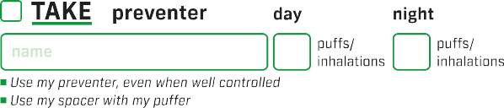





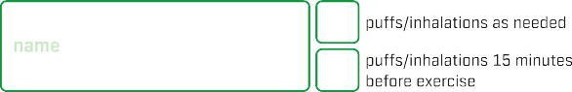

a
-
N
a
N
"::,'
Oil
::,
<t
"'
<"_{D}'
>





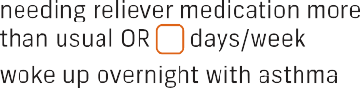


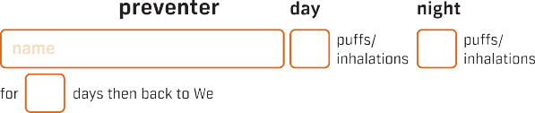
:::s
-
⁰>-
...
0

c^{C}u

.^{i}.⁵...
(.J
.Q.) .
0
(.J
Q)
.J:...
(/J
(/J
:::s
(.J
.!!!
"CJ



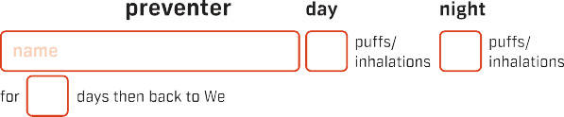

'.i..

.0...
(.J
0 "CJ
...
:::s
⁰>­
.:
Q)
>

Q)

Q)
...

:::s
⁰>­
(/J
cu

Q)
·cC::;
"CJ
Q)
E

.0...
cu
E E
cu
;;:::
C
....






ASTHMA FIRST AID




1
SIT THE PERSON UPRIGHT
- Be calm and reassuring.
- Do not leave them alone.
2
GIVE 4 SEPARATE PUFFS OF BLUE/ GREY RELIEVER PUFFER
- Shake puffer.
- Put 1 puff into spacer.
- Take 4 breaths from spacer.
- Repeat until 4 puffs have been taken
OR give 2 separate inhalations of Bricanyl (6 years or older)
OR give 1 inhalation of Symbicort Turbuhaler (12 years or older)
OR give 2 puffs of Symbicort Rapihaler through a spacer (12 years or older)
If no spacer available: Take 1 puff as you take 1 slow, deep breath and hold breath for as long as comfortable. Repeat until all puffs are given.
3
WAIT 4 MINUTES
- If there is no improvement, give 4 more separate puffs of blue/grey reliever as above.
OR give 1 more inhalation of Bricanyl.
OR give 1 more inhalation of Symbicort Turbuhaler
OR give 2 puffs of Symbicort Rapihaler through a spacer.

IF THERE IS STILL NO IMPROVEMENT
4
..._
000
•
DIAL TRIPLE ZERO (000)
Say 'ambulance' and that someone is having an asthma attack.
- Keep giving 4 separate puffs every 4 minutes.
until emergency assistance arrives
OR give 1 inhalation of a Bricanyl or Symbicort Turbuhal er every 4 minutes - up to a max of 4 more inhalations of Symbicort Turbuhaler
OR give 2 puffs of Symbicort Rapihaler through a spacer every 4 minutes - up to a max of 8 more puffs of Symbicort Rapihaler

Translating and Interpreting Service 131450
•

CALL EMERGENCY ASSISTANCE IMMEDIATELY AND DIAL TRIPLE ZERO (000) IF:
- the person is not breathing.
- the person's asthma suddenly becomes worse or is not improving.
- the person is having an asthma attack, and a reliever is not available.
- you are not sure if it is asthma.
- the person is known to have anaphylaxis - follow their Anaphylaxis Action Plan, then give Asthma First Aid
Blue/grey reliever medication is unlikely to harm, even if the person does not have asthma.
mJ

ASTHMA AUSTRALIA
1800 ASTHMA
(1800 278 462)
asthma.org.au

©Asthma Australia 2020

Management action plan
for children with coeliac disease
Name: DOB:
Emergency contacts:
Name: Name: Place
H: H: _
W: W: _ photo
M: M: _
here
Comments:

Review date:

If gluten is accidentally consumed, whilst not immediately life threatening, reactions that could occur include:
- Nausea and / or vomiting
- Diarrhea
- Constipation
- Fatigue, weakness, and lethargy
- Cramping and bloating
- Irritability and other abnormal behaviour

Reactions are different for every child, so if gluten is accidentally consumed, please contact the parent or carer immediately or obtain medical assistance.
For further information contact  Coeliac Australia  1300 458 836 www.coeliac.org.au | 











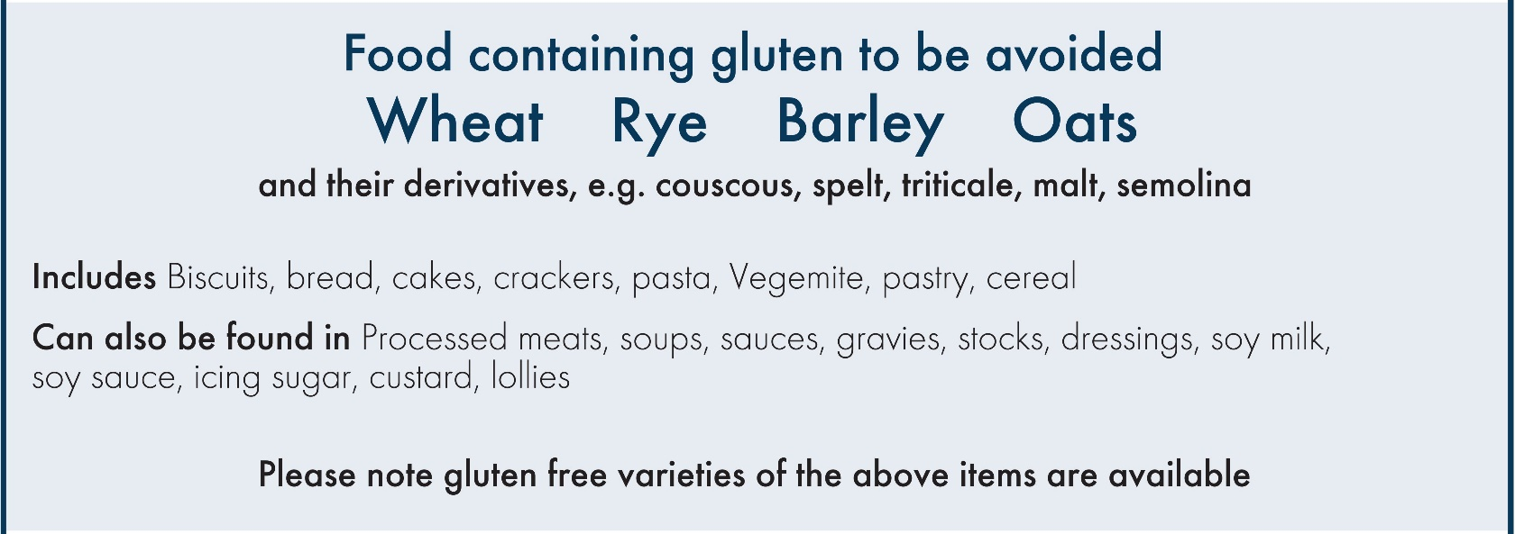
Coeliac Australia is not a medical organisation. The advice of a medical practitioner should always be obtained.

