 |  |  |  |  |  |  |  |  |  |  |  |  |  |  |  |  |  |  |  | 
 |  |  |  |  |  |  |  |  |  |  | Dear Parents, Guardians
 |  |  |  |  |  |  |  |  |  |  | We are pleased to advise that we will be using |  |  |  |  |  |  |  |  |  |  |  | Jaybel Office Choice |  | for the 2027 back to school packs.
Jaybel is a 100% Australian family-owned & operated school supplier. We've been working with Jaybel to ensure your child has an easy start to the new year.
We have selected the best products and quantities that we believe will cover your child’s needs for the year.
 |  |  |  |  |  |  |  |  | Please ensure that your child has everything listed on this form to start the 2027 school year.
 |  |  |  |  |  |  |  | Placing Orders
 |  |  |  |  |  |  |  |  |  |  |  |  |  | Ordering is fast, secure, and convenient. Simply visit www.jaybel.officechoice.com.au/booklists
 |  |  |  |  |  |  |  |  |  |  |  |  |  | Enter your school code and password, then follow the easy ordering steps.
 |  |  |  |  |  |  |  |  |  |  |  |  |  | Your School Code: BTSBS001 & Password: BS2027
 |  |  |  |  |  |  |  |  |  | Important Delivery Information
 |  |  |  |  |  |  |  |  |  |  |  |  |  | Orders placed before 11 Dec 2026 will receive FREE delivery. Orders placed after this date will incur a delivery fee of $9.95.
 |  |  |  |  |  |  |  |  |  |  |  |  |  | Please note that all orders will incur a packing fee of $2.95 (incl. GST).
 |  |  |  |  |  |  |  |  |  |  |  |  |  | To ensure your packs are delivered prior to school starting, please order |  |  |  |  |  |  |  |  |  |  |  | before |  | 05 Jan 2027.
 |  |  |  |  |  |  |  |  |  |  |  |  |  | Deliveries will commence on or before 01 Dec 2026. Orders are shipped with Authority to leave and do not require a signature on delivery.
 |  |  |  |  |  |  |  |  |  |  |  |  |  |  | Once your order has been despatched, |  |  |  |  |  |  | you will receive a tracking number via email.
 |  |  |  |  | Need Help?
 |  |  |  |  |  | For assistance with the website, your order, delivery information, or a general enquiry, please contact Jaybel Office Choice:
 |  |  |  |  |  |  | Email: |  |  |  |  |  |  |  |  | sales@jaybel.com.au
 |  |  |  |  |  |  | Phone: |  |  |  |  |  |  |  |  |  | 07 3423 5888
 |  |  |  |  |  | If your order hasn't arrived by 15 Jan 2027, please contact us.
 |  |  |  |  |  |  |  |  |  |  |  |  |  |  |  |  |  | We look forward to a successful start to the 2027 school year.
 |  |  |  |  |  |  |  | 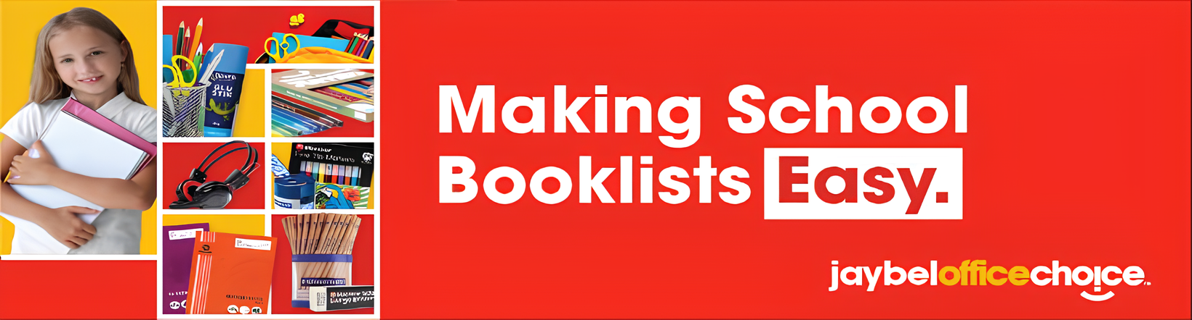

 |  |  |  |  |  |  |  | 
 |  |  |  | Bundamba State School
 |  |  |  | Year 3
 | PRODUCT |  |  |  | QTY | INC GST |  |  | TOTAL
 | CRAYOLA SUPER TIPS WASHABLE MARKERS ASSORTED PACK OF 10 |  |  |  | 1 | $ 4.14 |  |  | $ 4.14
 | CLEAR GLUE STICK 36GM |  |  |  | 6 | $ 1.17 |  |  | $ 7.00
 | FABER ECONOMY 1111 GRAPHITE PENCIL HB BOX OF 12 |  |  |  | 3 | $ 2.98 |  |  | $ 8.94
 | FABER-CASTELL TEXTLINER 46 HIGHLIGHTERS CHISEL 1-5MM ICE ASSORTED COLOURS PACK OF 4 |  |  |  | 1 | $ 5.68 |  |  | $ 5.68
 | POLISHED WOODEN RULER 30CM |  |  |  | 1 | $ 0.68 |  |  | $ 0.68
 | SCHOOL ERASER LARGE |  |  |  | 4 | $ 0.37 |  |  | $ 1.50
 | MAGNETIC MINI WHITEBOARD WIPER |  |  |  | 1 | $ 0.89 |  |  | $ 0.89
 | NAME PENCIL CASE 345X165MM LARGE |  |  |  | 1 | $ 2.71 |  |  | $ 2.71
 | PVC CLIPFOLDER A4 ASSORTED COLOURS |  |  |  | 1 | $ 3.32 |  |  | $ 3.32
 | STAEDTLER HEXAGONAL BASIC COLOURED PENCILS ASSORTED BOX OF 12 |  |  |  | 2 | $ 2.40 |  |  | $ 4.80
 | EXERCISE BOOK YEAR 3/4 A4 12MM RULED 48 PAGES WITH MARGIN |  |  |  | 6 | $ 1.07 |  |  | $ 6.40
 | WHITEBOARD MARKER BULLET TIP BLACK |  |  |  | 6 | $ 0.68 |  |  | $ 4.09
 | MARBIG DOCULOPE WALLET A4 WITH BUTTON CLOSURE CLEAR |  |  |  | 1 | $ 0.76 |  |  | $ 0.76
 | SCRAPBOOK 335X240MM BLANK 64 PAGES |  |  |  | 4 | $ 2.11 |  |  | $ 8.45
 | GRAPH BOOK A4 10MM RULED 48 PAGES |  |  |  | 2 | $ 1.03 |  |  | $ 2.07
 | SCRIBBLE TO SCRIPT FOR QUEENSLAND BOOK 3 |  |  |  | 1 | $ 19.44 |  |  | $ 19.44
 | A3 MESH POUCH |  |  |  | 1 | $ 5.64 |  |  | $ 5.64
 | Please choose only one of the below scissor:
 | SCISSOR 165MM RIGHT HAND |  |  |  | 1 | $ 2.79 |  |  | $ 2.79
 | OR
 | SCISSOR 165MM LEFT HAND |  |  |  | 0 | $ 2.79 |  |  | $ 0.00
 | MARBIG DOCULOPE WALLET A3 WITH BUTTON CLOSURE AND TITLE HOLDER CLEAR |  |  |  | 1 | $ 2.79 |  |  | $ 2.79
 | SHARPENER PLASTIC BARREL DOUBLE HOLE |  |  |  | 2 | $ 0.72 |  |  | $ 1.43
 |  |  |  |  | Total of Inc GST |  |  |  | $ 93.52

